Creating reels using Canva

BON APPETITE RESTAURANT

1. INTRODUCTION:

1.1.OVERVIEW :

Our grand opening reel project for our restaurant(BON APPETITE) in digital marketing is a strategic campaign designed to create excitement and anticipation around the launch of in our restaurant. It leverages short video content to engage potential customers , drive foot traffic to the grand opening event ,often in the form of reels, to promote a restaurant's brand, menu, dining experience on social media platforms, By using appealing visuals, mouth-watering sounds, and clear captions to our entice followers to come and try our food.

1.2.PURPOSES :

The purpose of this content has been visually appealing, engaging, and reflect the personality and uniqueness of our restaurant. Our restaurant reel project in digital marketing is comprehensive strategy to leverage short video clip, often in the form of reel , to promote a restaurant brand, menu, and dining experience on social media platform. A well-crafted grand opening reel can generate excitement, drive attendance, and set the stage for a successful launch.

2.PROBLEM DEFINITION & DESIGN THINKING:

2.1.EMPATHY MAP :

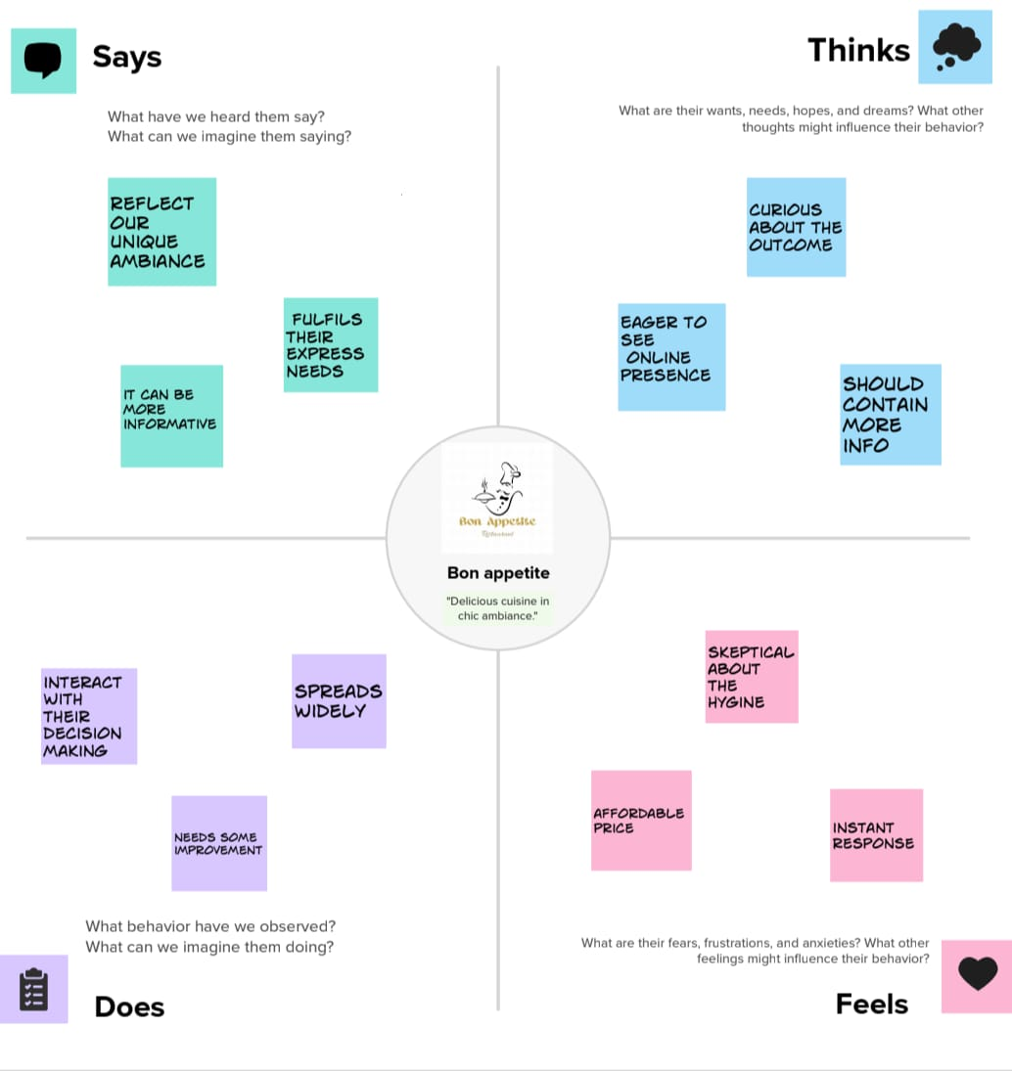

2.2.IDEATION & BRAINSTORMING MAP :

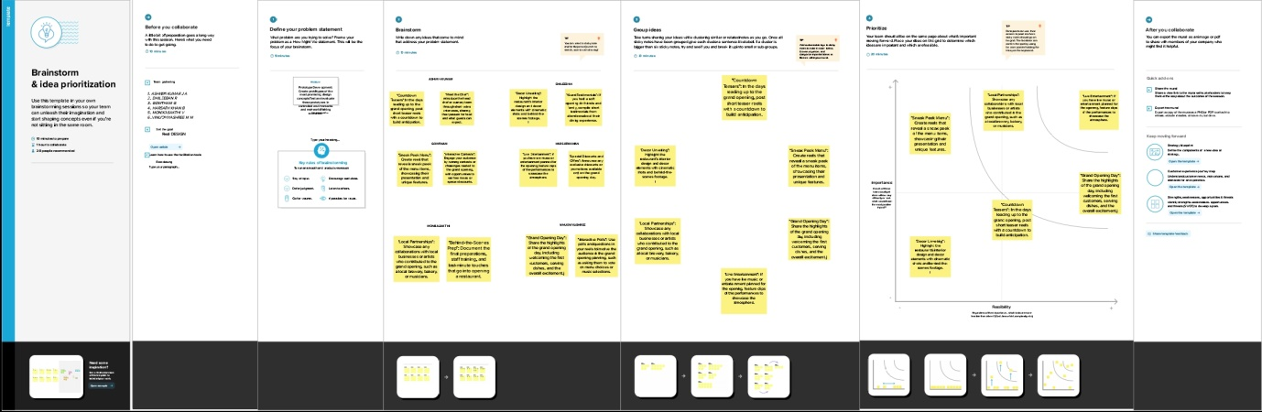

3. RESULT :

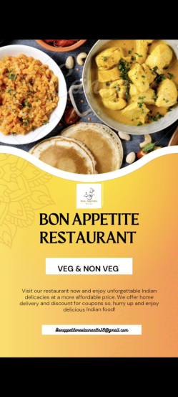

4.ADVANTAGES &DISADVANTAGES:

* Positives -It is easy to create a reel using canva
* Easy to download and beginner friendly
* Negatives- has to much content in premium version
* Has water mark on downloaded content if your are downloading a premium content

5.APPLICATIONS:

Reels created using Canva, a popular graphic design platform, can serve a variety of purposes across different industries and personal endeavors. Here are some common uses for reels created using Canva

* Social media marketing
* Ease in promotions and announcements
* It can be used without spending money
* It requires minimal knowledge

6.conclusions :

Our team assigned to project-CREATE A REEL USING CANVA . creating an account on canva’s website. once logged in , click ‘create a design’ and set custom dimensions (1080\*1920)for instagram reels .design your reel cover using canva’s templates , background options ,text styles and graphics .upload images or videos. customize elements by adjusting size, position and style . arrange and after completing click ’download’ to save